1. TA自編題目_112下-5 :(pointer, aray)_ 基本陣列操作

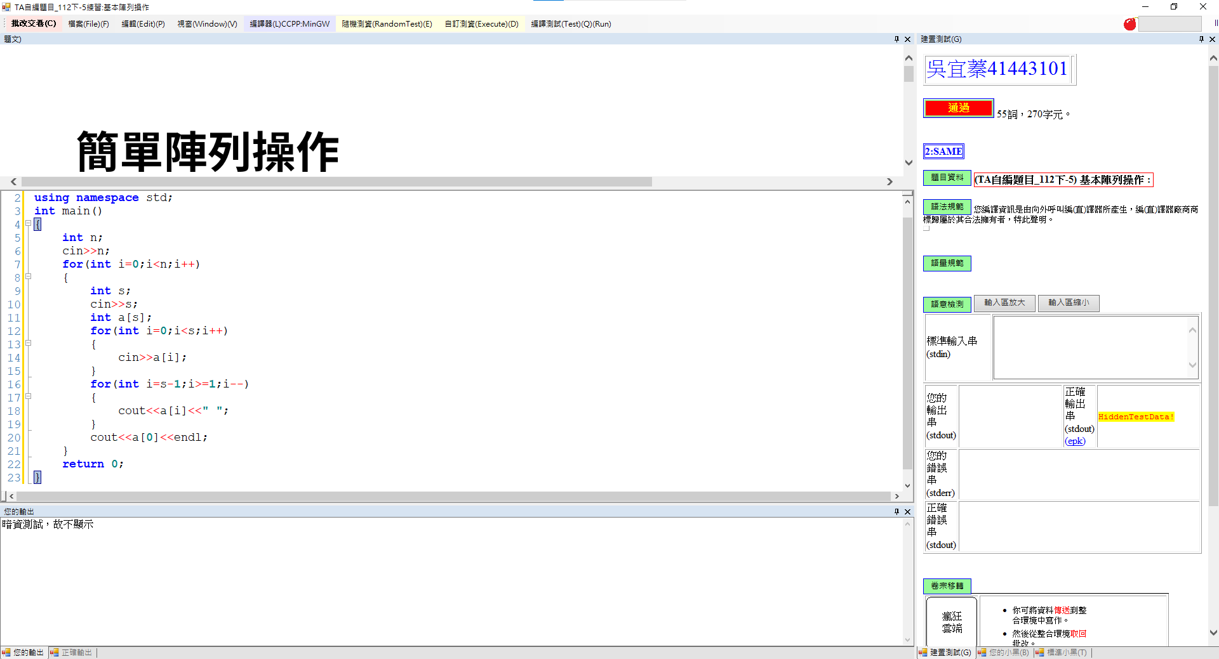

2. TA自編題目_112下-28 :(recursion )_ GCD

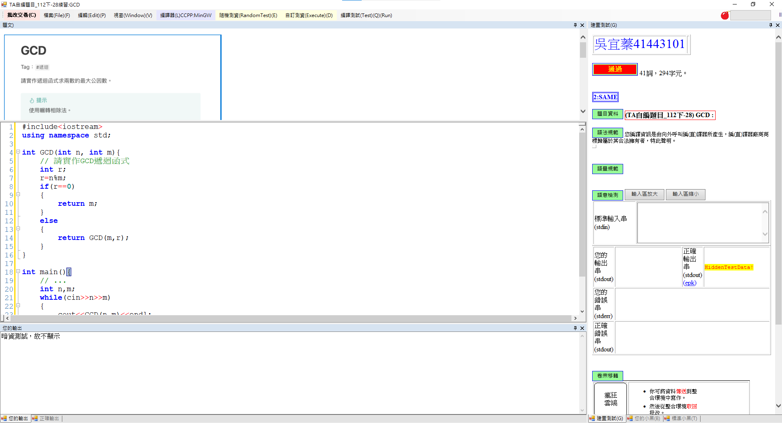

3. TA自編題目_112下-26 :(binary search)_ Binary Search

